Introduction to Python: Gradient Descent, Back Propagation, and Numerical Gradient Checking
Laboratory Exercise 8

Antonio, Daniel
Electronics and Communications Engineering Department
De La Salle University - Manila
Manila, Philippines

Eco, Lance Randall Lim
Electronics and Communications Engineering Department
De La Salle University – Manila
Manila, Philippines
lance_eco@dlsu.edu.ph

Tan, Sidney Sheldon Urlanda
Electronics and Communications Engineering Department
De La Salle University - Manila
Manila, Philippines
sidney_tan@dlsu.edu.ph

Zarzoso, Aaron John Pascua
Electronics and Communications Engineering Department
De La Salle University - Manila
Manila, Philippines
aaron_zarzoso@dlsu.edu.ph

Abstract—This document represents the students’ lab report for experiment 8 of the course LBYCP29. It contains the procedures done in the implementation of a new programming language that is used which is Python. Anaconda which is the packet manager is required to program and code gradient descent, back propagation and numerical gradient checking. Anaconda is also a collection of open source packages that is within Python.
Keywords— python; anaconda; gradient descent; neural networks; back propagation; numerical gradient checking;

Introduction
The main programming language that is used in this particular experiment is Python which is very similar. Through this programming language, it will be able to use interactive model and will therefore allow the examination of snippet codes. Also, through this programming language, it will be able to connect different components together. This is because Python utilizes and contains a top level data structure that would enable this procedure. Meanwhile, due to the increased productivity that it gives there are a lot of programmers that utilize this programming language. On the other hand, there are a lot of applications that utilize Python. These programs are namely gradient descent, back propagation, and numerical gradient check. Let us further elaborate these implementations. For gradient descent, as we all know from previous experiments the goal is to minimize the given functions which is the cost function through an algorithm. This is done so that the data will have a minimal error or close to the actual value. Meanwhile, backward propagation or back propagation utilizes neural networks in an optimization method. This is done in order to compute for the gradient’s loss function. Finally, we have numerical gradient checking where it would allow the user to check the derivative and every dimension of the gradient.
.

Instructions/procedure

Gradient Descent
The group started with Gradient descent and ran the code, unfortunately it did not work because it was missing some codes. The group proceeded to add:
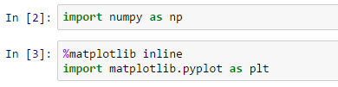
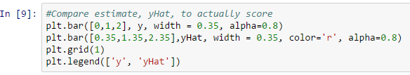
And added “plt” as a prefix to all plot and bar commands.
We then initialize the network by using the forward method done on part 2
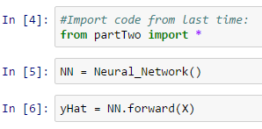
Before showing the resulting yHat and values of y (actual score).
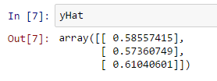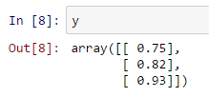
Then the group compared the yHat and actual score (y) by tabulation.
To check for the 1000 different weight values of our neural network, the group used the codes:

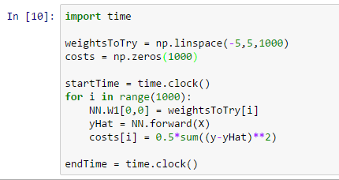

The time it took to check 1000 different weight values for our neural network. Since we’ve computed the cost for a wide range values of W, we can just pick the one with the smallest cost, let that be our weight, and we’ve trained our network.

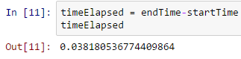

The cost vs the weight is then plotted. Before we optimize through, let's consider the full complexity of the problem. Remember the 0.04 seconds required is only for one weight, and we have 9 total! Let's next consider 2 weights for a moment. To maintain the same precision we now need to check 1000 times 1000, or one million values. This is a lot of work, even for a fast computer.
Code used to time the checking of 1000 times 1000 weights:
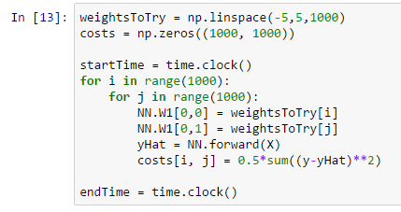
After our 1 million evaluations we’ve found our solution, using the code:
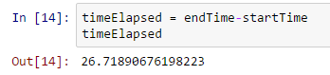

Back Propagation
The group started with Gradient descent and ran the code, unfortunately it did not work because it was missing some codes. The group proceeded to add:

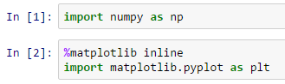

The group added “plt” as a prefix to all plot and bar commands.
Now is a good time to add a new python method for the derivative of our sigmoid function, sigmoid Prime. Our derivative should be the largest where our sigmoid function is the steepest, at the value z equals zero.

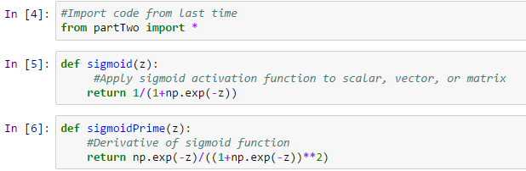

Code to plot the values for sigmoid and sigmoidPrime:

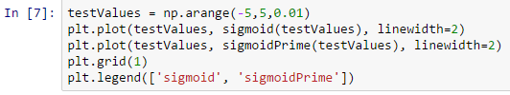

Then the group plotted the sigmoid and sigmoid prime.
We’ll code up our gradients in python in a new method, cost function prime. Numpy’s multiply method performs element-wise multiplication, and the dot method performs matrix multiplication.

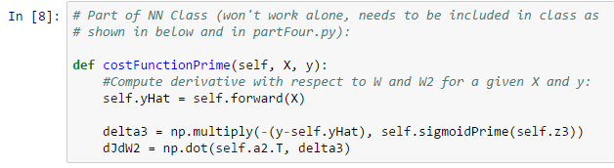

We have one final term to compute: dJ/dW1. All that’s left is to code this equation up in python. What’s cool here is that if we want to make a deeper neural network, we could just stack a bunch of these operations together.
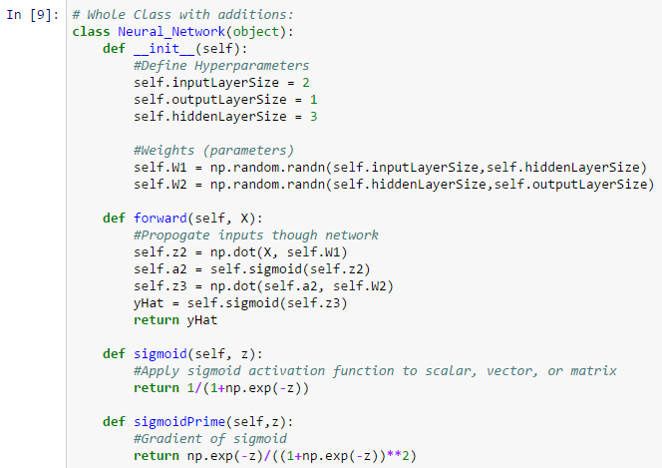
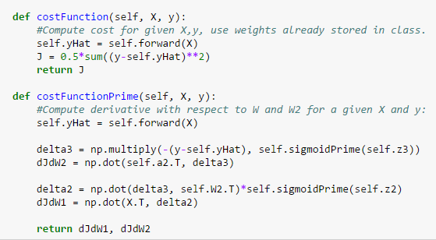
So how should we change our W’s to decrease our cost? We can now compute dJ/dW, which tells us which way is uphill in our 9 dimensional optimization space.
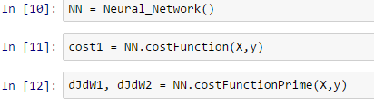
Before displaying the computed values for dJdW1 and dJdW2.
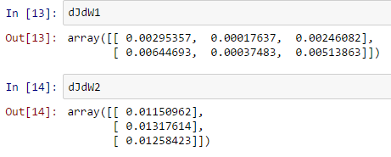
If we move this way by adding a scalar times our derivative to our weights, our cost will increase, and if we do the opposite, subtract our gradient from our weights, we will move downhill and reduce our cost. This simple step downhill is the core of gradient descent and a key part of how even very sophisticated learning algorithms are trained.
In 16: cost increases, in 18: cost decreases
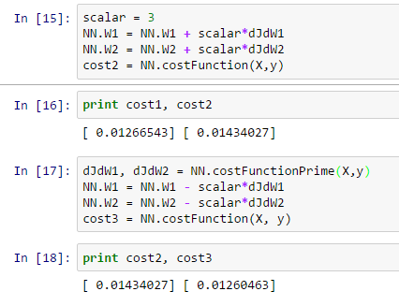

Numerical Gradient Checking
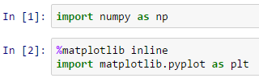

Let’s test our method with a simple function, x squared. We’ll choose a reasonable small value for epsilon, and compute the slope of x^2 at a given point by finding the function value just above and just below our test point. We can then compare our result to our symbolic derivative 2x, at the test point. If the numbers match, we’re in business!

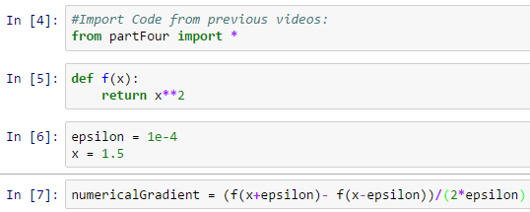

The comparison of the results are coded and shown to be almost a match.

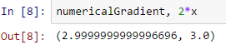

Add helper functions to our neural network class:

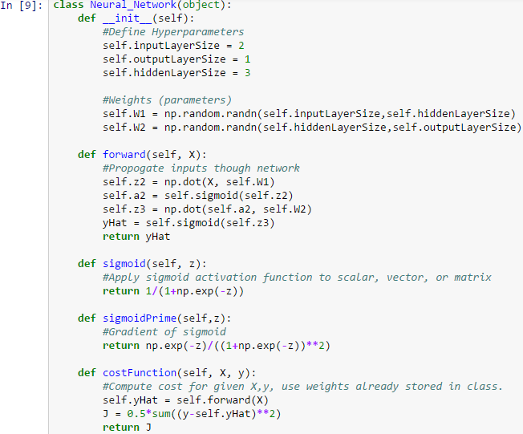
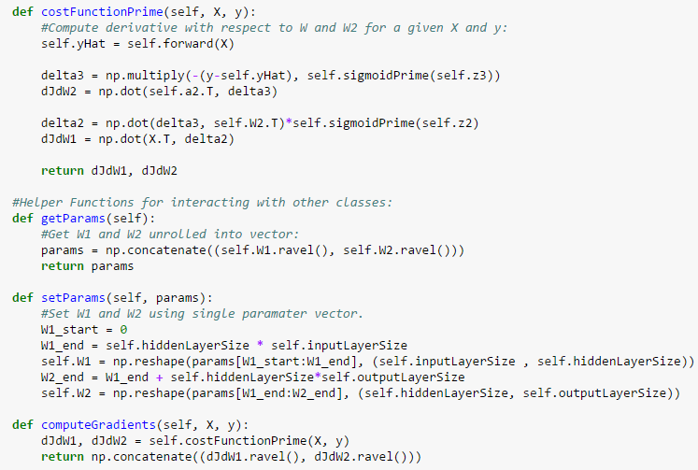

We can use the same approach to numerically evaluate the gradient of our neural network. It’s a little more complicated this time, since we have 9 gradient values, and we’re interested in the gradient of our cost function. We’ll make things simpler by testing one gradient at a time. We’ll “perturb” each weight - adding epsilon to the current value and computing the cost function, subtracting epsilon from the current value and computing the cost function, and then computing the slope between these two values.

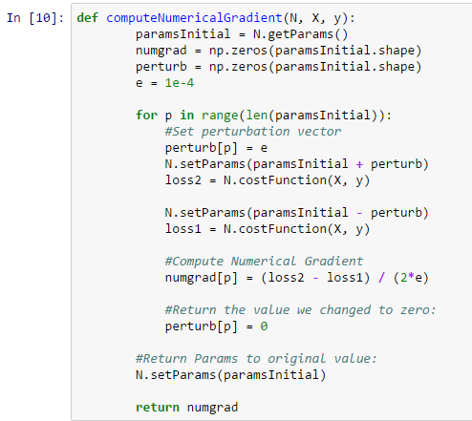

We’ll repeat this process across all our weights, and when we’re done we’ll have a numerical gradient vector, with the same number of values as we have weights. It’s this vector we would like to compare to our official gradient calculation. Comparison of the numerical gradient vector with the official gradient.

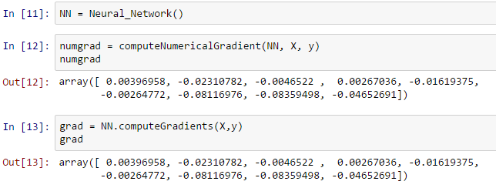
We see that our vectors appear very similar, which is a good sign, but we need to quantify just how similar they are.
A nice way to do this is to divide the norm of the difference by the norm of the sum of the vectors we would like to compare. Typical results should be on the order of 10^-8 or less if you’ve computed your gradient correctly.

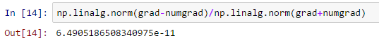

And that’s it, we can now check our computations and eliminate gradient errors before they become a problem. Next time we’ll train our Neural Network.

Data and results

Gradient Descent
Fig. 1. Resulting yHat.

Fig. 2. Values of y (actual score).

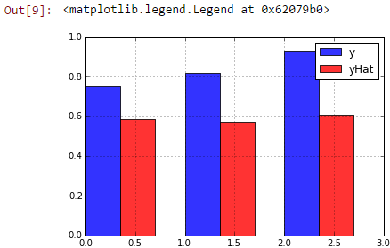
Fig. 3. Comparison of yHat and actual score (y).

Fig. 4. Time it takes to determine 1000 different weigh values of the neural network.
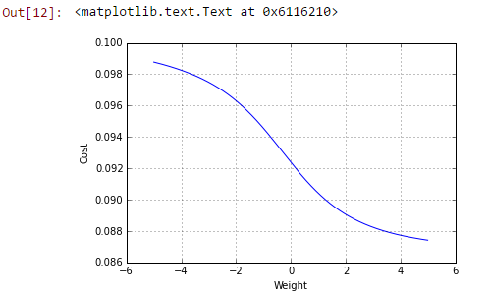
Fig. 5. Plot of the cost vs the weight.

Fig. 6. Time elapsed.

Back Propagation
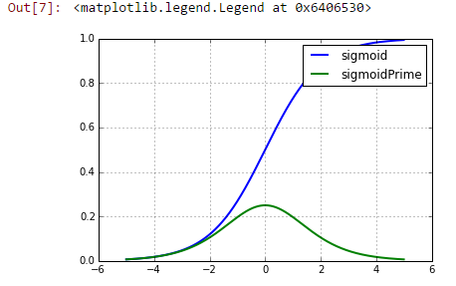
Fig. 7. Plot of sigmoid and sigmoid prime.

Fig. 8. Computed values for dJdW1 and dJdW2.
Fig. 9. Outputs 16 (cost increases) and 18 (cost decreases).

Numerical Gradient Checking
Fig. 10. Output of the numerical gradient which shows that the comparison of the results are almost a match.

Fig. 11. Comparison of the numerical gradient vector with the official gradient.

Fig. 12. Result of dividing the norm of the difference by the norm of the sum of the vectors.

analysis and conclusion
In this experiment, the students were able to make use of a new software that is called Jupyter notebook. Jupyter notebook is a software that can simulate files which will be used in the following experiment. It can allow the user to simulate python based on the codes in the browser and the given files were access from the command prompt of anaconda which the default browser will appear. The given codes were incomplete which the group fills the missing codes that successfully run the simulations. Overall, the experiment established the group to neural networks through the python simulation on the Jupyter notebook.

References
- MathWorks. (N.D.). MATLAB - The Language of Technical Computing. [Online]. Available: http://www.mathworks.com/
products/matlab/
- Eaton, J. (N.D.). About GNU Octave. [Online]. Available: https://www.gnu.org/software/octave/about.html
- Python Software Foundation. (N.D.). What is Python? Executive Summary. [Online]. Available: https://www.python.org/doc/essays
/blurb/
- McCollum, P. (N.D.). An Introduction to Back-Propagation Neural Networks. [Online]. Available: http://www.seattlerobotics.org/
encoder/nov98/neural.html
- N.A. (N.D.). CS231n Convolutional Neural Networks for Visual Recognition. [Online]. Available: http://cs231n.github.io/neural-networks-3/#gradcheck

